

MUHAMMAD WAQAR ARSHAD

01-134122-076

Live Traffic Road Sign Detection

Bachelor of Science in Computer Science

Department of Computer Science

Bahria University, Islamabad

November 2016

c Muhammad Waqar Arshad, 2016

Contents

1 Introduction 1

1.1 Overview . . . . . . . . . . . . . . . . . . . . . . . . . . . . . . . . . . 1

1.2 Problem Description . . . . . . . . . . . . . . . . . . . . . . . . . . . . 1

1.3 Objectives . . . . . . . . . . . . . . . . . . . . . . . . . . . . . . . . . . 2

1.4 Problem Scope . . . . . . . . . . . . . . . . . . . . . . . . . . . . . . . 2

1.5 Methodology . . . . . . . . . . . . . . . . . . . . . . . . . . . . . . . . 2

1.6 System Overview Diagram . . . . . . . . . . . . . . . . . . . . . . . . . 2

1.7 Tools/Technology . . . . . . . . . . . . . . . . . . . . . . . . . . . . . . 3

2 Literature Review 5

2.1 Previous Research and Study . . . . . . . . . . . . . . . . . . . . . . . . 5

3 Requirement Specifications 7

3.1 Purpose of Document . . . . . . . . . . . . . . . . . . . . . . . . . . . . 7

3.2 System Overview and Scope . . . . . . . . . . . . . . . . . . . . . . . . 7

3.3 Product Functions . . . . . . . . . . . . . . . . . . . . . . . . . . . . . . 7

3.4 User Characteristics . . . . . . . . . . . . . . . . . . . . . . . . . . . . . 7

3.5 Operating Envoirment . . . . . . . . . . . . . . . . . . . . . . . . . . . . 8

3.6 Constraints, Assumptions and Dependencies . . . . . . . . . . . . . . . . 8

3.7 Description . . . . . . . . . . . . . . . . . . . . . . . . . . . . . . . . . 8

3.8 Importance . . . . . . . . . . . . . . . . . . . . . . . . . . . . . . . . . 8

3.9 Benefit . . . . . . . . . . . . . . . . . . . . . . . . . . . . . . . . . . . . 9

3.10 Criticality . . . . . . . . . . . . . . . . . . . . . . . . . . . . . . . . . . 9

3.11 Technical Issues/Risks . . . . . . . . . . . . . . . . . . . . . . . . . . . 9

3.12 Performance Requirements . . . . . . . . . . . . . . . . . . . . . . . . . 9

3.13 SQR-01 . . . . . . . . . . . . . . . . . . . . . . . . . . . . . . . . . . . 9

3.14 SQR-02 . . . . . . . . . . . . . . . . . . . . . . . . . . . . . . . . . . . 9

3.15 Availability . . . . . . . . . . . . . . . . . . . . . . . . . . . . . . . . . 10
3.16 Flexibility . . . . . . . . . . . . . . . . . . . . . . . . . . . . . . . . . . 10

3.17 Usability . . . . . . . . . . . . . . . . . . . . . . . . . . . . . . . . . . . 10

3.18 Accuracy . . . . . . . . . . . . . . . . . . . . . . . . . . . . . . . . . . 10

3.19 Maintainability . . . . . . . . . . . . . . . . . . . . . . . . . . . . . . . 10

3.20 Portability . . . . . . . . . . . . . . . . . . . . . . . . . . . . . . . . . . 10

4 Design 11
4.1 Actors . . . . . . . . . . . . . . . . . . . . . . . . . . . . . . . . . . . . 11
4.2 Use Case . . . . . . . . . . . . . . . . . . . . . . . . . . . . . . . . . . 11

i
 | ii |  |  |  | CONTENTS
 | 4.3 | Flow Chart . . . . . | . . . . . . . . . . . . . . . . | . . . . . . . . | . . . . 14
 | 4.4 | Component Diagram | . . . . . . . . . . . . . . . . | . . . . . . . . | . . . . 15
 | 4.5 | Block Diagram . . . | . . . . . . . . . . . . . . . . | . . . . . . . . | . . . . 16
 | 4.6 | Package Diagram . . | . . . . . . . . . . . . . . . . | . . . . . . . . | . . . . 17
 | 4.7 | Colaboration Diagram | . . . . . . . . . . . . . . . | . . . . . . . . | . . . . 18
 | 4.8 | Sequence Diagram . | . . . . . . . . . . . . . . . . | . . . . . . . . | . . . . 19
 | 4.9 | Deployment Diagram . . | . . . . . . . . . . . . . . . . . . . . . | . . . . . | 20
 | 4.10 System Overview Diagram . . . . . . . . . . . . . . . . . . . . . . . . . |  |  |  | 21
5 System Implementation |  |  |  |  | 23
 | 5.1 | Tools and Technology . . . . . . . . . . . . . . . . . . . . . . |  | . . . . . . | 23
 | 5.2 | Methodology and Algorithmic Development . . . . . . . . . . . . . |  |  | . . .24
6 | System Testing and Evaluation |  |  |  | 27
 | 6.1 | Introduction . . . . . . . . . . | . . . . . . . . . . . . . . . . . . . . . . . |  | 27
 | 6.2 | Testing . . . . . . . . . . . . . . . . . . . . . . . . . . . . . . . . . . |  | . . | 27
 | 6.3 | Usability Testing . . . . . . . . . . . . . . . . . . . . . . . . . . |  | . . . . | 27
 | 6.4 | Project Running Testing | . . . . . . . . . . . . . . . . . . . . | . . . . . . | 27
 | 6.5 | Compatibility Testing . . . . . . . . . . . . . . . . . . . . . . |  | . . . . . | 28
 | 6.6 | Test Plan . . . . . . . . . . . . . . . . . . . . . . . . . . . . . . . . . . . |  |  | 28
 | 6.7 | Objectives of testing . . . . . . . . . . . . . . . . . . . . . . . |  | . . . . . | 28
 | 6.8 | Testing techniques . . . . . . . . . . . . . . . . . . . . . . . . . . . . . |  |  | 28
 | 6.9 | Testing Scope . . . . . . . . . . . . . . . . . . . . . . . . . . . . . . . . |  |  | 28
 | 6.10 | Test Cases . . . . . . . . . . | . . . . . . . . . . . . . . . . . . . . . | . . . | 28
7 | Conclusions |  |  |  | 31
 | 7.1 | Major Accomplishments | . . . . . . . . . . . . . . . . . . . . . . . . . . |  | 31
 | 7.2 | Limitations . . . . . . . . . . | . . . . . . . . . . . . . . . . . . . . . | . . | 31
 | 7.3 | Future Enhancements . . . . . . . . . . . . . . . . . . . . . . |  | . . . . . . | 31
References |  |  |  |  | 33

iv LIST OF FIGURES

List of Figures

1.1 System Overview Diagram . . . . . . . . . . . . . . . . . . . . . . . . . 3

4.1 Use Case . . . . . . . . . . . . . . . . . . . . . . . . . . . . . . . . . . 12

4.2 Flow Chart . . . . . . . . . . . . . . . . . . . . . . . . . . . . . . . . . 14

4.3 Component Diagram . . . . . . . . . . . . . . . . . . . . . . . . . . . . 15

4.4 Block Diagram . . . . . . . . . . . . . . . . . . . . . . . . . . . . . . . 16

4.5 Package Diagram . . . . . . . . . . . . . . . . . . . . . . . . . . . . . . 17

4.6 Colaboration Diagram . . . . . . . . . . . . . . . . . . . . . . . . . . . 18

4.7 Sequence Diagram . . . . . . . . . . . . . . . . . . . . . . . . . . . . . 19
4.8 Deployment Diagram . . . . . . . . . . . . . . . . . . . . . . . . . . . . 20

4.9 System Overview Diagram . . . . . . . . . . . . . . . . . . . . . . . . . 21

iii

vi LIST OF TABLES

List of Tables

4.1 Usecase 1 - Starting Application . . . . . . . . . . . . . . . . . . . . . . 13

4.2 Usecase 2 - Colour Based Thresholding . . . . . . . . . . . . . . . . . . 13

4.3 Usecase 3 - Shape Detection . . . . . . . . . . . . . . . . . . . . . . . . 13
4.4 Usecase 4 - Shape Recognition . . . . . . . . . . . . . . . . . . . . . . . 13

4.5 Usecase 5 - Text Extraction . . . . . . . . . . . . . . . . . . . . . . . . . 13

4.6 Usecase 6 - Text to Speech . . . . . . . . . . . . . . . . . . . . . . . . . 14

6.1 Test Case-1: Getting Image . . . . . . . . . . . . . . . . . . . . . . . . 29

6.2 Test Case-2: Convert Image to HSV . . . . . . . . . . . . . . . . . . . . 29

6.3 Test Case-3: Color based Thresholding . . . . . . . . . . . . . . . . . . 29

6.4 Test Case-4: Canny Edge Detection . . . . . . . . . . . . . . . . . . . . 29
6.5 Test Case-5: Shape Detection . . . . . . . . . . . . . . . . . . . . . . . . 30

6.6 Test Case-6: Features Extraction . . . . . . . . . . . . . . . . . . . . . . 30

v

Chapter 1

Introduction

1.1 Overview

The road signs are very important, they play a major role in preventing the accidents but they are ignored frequently by the drivers. This puts their life and the life of other passengers at risk. Especially at long routes drivers are much careless regarding the traffic road signs.this will be an application which helps the driver to concentrate on the road. It tells the driver about the traffic signs by scanning the signs and speaking it to the driver so that he or she wouldn’t miss any traffic signs.

Problem Description

Project Objectives

Project Scope

Methodology

System Overview Diagram

Tools/Technology

1.2 Problem Description

In our routine we can observe that due to the number of cars increasing every day the roads are crowded, and they are getting busy day by day. The driver has to concentrate on the road which leads to the problem that in doing that, the driver misses most of the road signs. Especially on the long routes, drivers are much more careless about the traffic signs.This eventually can cause serious accidents. To prevent this situation, this application will speak

1
2 Introduction

the road signs to the driver so that he or she is aware of the road signs while concentrating on the traffic.

1.3 Objectives

Most people don’t realize the importance of the traffic signs and ignore then which can cause accidents. The objective of our application is to detect, recognize and speak traffic signs for the driver so that the driver doesn’t miss any of the signs. This application will be designed for Android Mobiles.

1.4 Problem Scope

This application will be android based. This system will detect the road signs and then recognize them. After the recognition of the road signs, the results will be sent to the driver as alerts. The Main Scope of this project is

Road Sign Detection

Recognition of the Sign

Speaking the Sign to driver

I will take approximately 10 signs from each class.Distance from car to the sign will be between 10 to 30 meters.

1.5 Methodology

This application will take live feed from the camera of the smart phone as an input and it will process it for shape recognition, after the correct identification of the shape, the process of color recognition of the road sign will be start. After shape and color of the road sign, the application will recognize, what the traffic sign is and after the correct recognition of the traffic sign it will be converted into text.The Converted text will be sent to the Google Text to Speech API where the text will be spoken to the driver as alerts.

1.6 System Overview Diagram

As shown in the System Overview Diagram, this will be an application which helps the driver to concentrate on the road. It tells the driver about the traffic signs by scanning the signs and speaking it to the driver so that he or she wouldn’t miss any traffic signs.
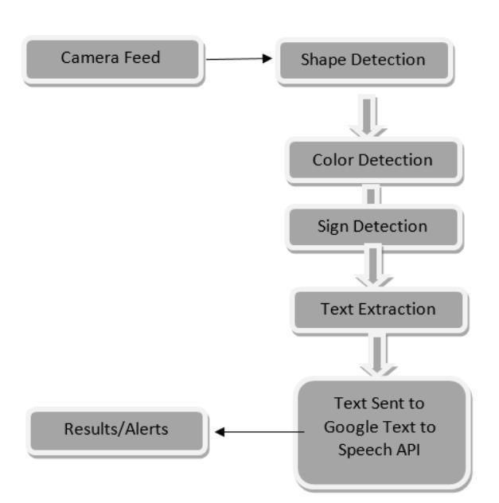

Figure 1.1: System Overview Diagram
1.7 Tools/Technology 3

1.7 Tools/Technology

Hardware

Android Smartphone Software

Android Studio Libraries

Tesseract

OCR OpenCV

4 Introduction

Chapter 2

Literature Review

2.1 Previous Research and Study

This paper presents the effective method for efficient detection and recognition of road signs. The detection is based on color segmentation using HSV and Shape detection using hough transform. SIFT, SURF and BRISK are the feature matching algorithms used for the effective recognition of road signs.consecutive frames are taken because the neighboring frames show temporal redundancy so the it gives us improved detection rate. the text based output can be generated to the driver using OCR and text to speech libraries.[1]

The authors Jack Greenhalgh and Majid Mirmehdi, propose an automatic detection and recognition of traffic sign system. This system detects the regions using MSERs, which helps in variation of light. SVMs are trained using HOG features. This system is accurate at high speed as it runs at 20 frames per second.[2]

In this paper by P. V. Nandha Kumar and R. Ganesamoorthy, Fast and real time detection of road signs and text using LVQ and SVM and the detection of text with OCR algorithms using MATLAB simulation. RGB images are taken with different conditions of weather and converted in HSV.[3]

Arasanipalai Mohan Aditya, Sagar Moharir wrote this paper about the Study of Traffic sign detection and recognition algorithms. the data set of images was in RGB converted to binary for couture of traffic sign. According to this paper Neural Networks with Learning Machines forms a structure with 99.40 percent accuracy.[4]

5
6 Literature Review

Chapter 3

Requirement Specifications

3.1 Purpose of Document

The purpose of the document is to describe the detail of live traffic road sign detection. This document is to explain the working, specification, functionalities, and constraints under which the system will operate and how it will behave with the external environment. This document describe all functional and non-functional requirements of the system.

3.2 System Overview and Scope

This will be an application which helps the driver to concentrate on the road. It tells the driver about the traffic signs by detecting, recognizing the signs and speaking it to the driver so that driver wouldn’t miss any traffic signs.

General Description

3.3 Product Functions

This Application can be used by placing an android smart phone on the dashboard of the car and it starts detecting the traffic road signs and then it recognizes the sign and then through the speaker the output will be generated. This Product is easy to use, by just clicking on the app it will start working.

3.4 User Characteristics

The system does not require any uncommon qualities for the users.The users are relied upon to be acquainted with android based smart phones. The System will be very easy to use. The only input required by the user is to click on the app to start.

7
8 Requirement Specifications

3.5 Operating Envoirment

The following software and libraries needed to be installed.

Windows 7 or above

Android Studio

Latest JDK’s and

SDK’s OpenCv 3.0

Tesseract OCR

3.6 Constraints, Assumptions and Dependencies

Visual Policies

use of application in low light can result to incorrect/improper results.

Angle Limitations

The smartphone should be placed on dashboard in landscape orietation for better results.

Sensitivity of system

Incase of road sign image is coverd by any ads or spray paint the system will not identify the road sign.

Functional Requirements

The main function of this system is to detect, recognize the traffic road signs.

3.7 Description

This Application will provide its services to the general public in their daily driving. the frames will be taken live from camera feed as images and different operations will be performed.

3.8 Importance

This Application is ideal for the drivers as it will help them to know about the signs and follow them.
3.9 Benefit | 9

3.9 Benefit

This Application will educate the drivers about the signs and this will solve most of the problems that occur on daily basis.

3.10 Criticality

The detection and recognition of traffic road sign is the most critical point of this applica-tion.

3.11 Technical Issues/Risks

The Application will not work properly and will give wrong/false results under following situations and conditions:

Road sign covered with ads and

paint Low Light

Road sign paint is worn off

Non-Functional Requirements

3.12 Performance Requirements

The Android Smartphone should have minimum Android 4.0.3 Ice Cream Sandwich API 15 with at least 8 Megapixel camera. The RAM should be minimum 512 MB.

Software Quality Requirements

3.13 SQR-01

This Application will be able to detect the traffic road sign with 99 percent accuracy.

3.14 SQR-02

This system should have availability to extended accordingly or be act as a module in other big system.
10 Requirement Specifications

3.15 Availability

This application will be available to general public.

3.16 Flexibility

The Application will be flexible for enough for some later requirements change or features enhancement

3.17 Usability

The interface and GUI design of the system will be user friendly with no training required to use the application.

Other Requirements

Some of the other specific non-functional attributes required by the system are given below:

3.18 Accuracy

The application should be accurate enough to detect the right traffic road sign.

3.19 Maintainability

The maintenance of the application will be carried out by the developer, if required.

3.20 Portability

The Application is portable because it runs on the mobile devices and the can be carried anywhere.

Chapter 4

Design

Use case

4.1 Actors

User

System

4.2 Use Case

Get Frame

Colour Based Thresholding

Shape Detection

Sign Recognition

Text Extraction

Text to Speech Api

11
12 Design
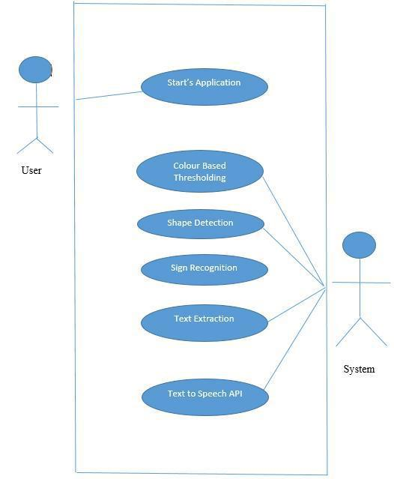

Figure 4.1: Use Case

4.2 Use Case | 13
Use Case Id |  | 1
Title |  | Start Application
Description |  | User starts the application on smartphone
Primary Actor |  | User
Pre-Condition |  | Application is Installed On the smartphone
Post-Condition |  | Application Should start properly
 | Table 4.1: Usecase 1 - Starting Application
Use Case Id |  | 2
Title |  | Colour Based Thresholding
Description |  | System applies colour based thresholding
Primary Actor |  | System
Pre-Condition |  | System has a coloured frame
Post-Condition |  | Red colour based thresholding is applied
 | Table 4.2: Usecase 2 - Colour Based Thresholding
Use Case Id |  | 3
Title |  | Shape Detection
Description |  | System will detect shapes from the frame
Primary Actor |  | System
Pre-Condition |  | Colour Based Thresholding is applied
Post-Condition |  | Shapes are detected
 | Table 4.3: Usecase 3 - Shape Detection
Use Case Id |  | 4
Title |  | Sign Recognition
Description |  | traffic signs will recognized
Primary Actor |  | System
Pre-Condition |  | Shapes are detected
Post-Condition |  | Traffic Signs are recognized
 | Table 4.4: Usecase 4 - Shape Recognition
Use Case Id |  | 5
Title |  | Text Extraction
Description |  | Text will be extracted
Primary Actor |  | System
Pre-Condition |  | Traffic signs are reconized
Post-Condition |  | Text should be generated

Table 4.5: Usecase 5 - Text Extraction

14 |  | Design
Use Case Id |  | 6
Title |  | Text To Speech
Description |  | Text will be spoken through speakers
Primary Actor |  | System
Pre-Condition |  | Traffic Signs are recognized
Post-Condition |  | Text will be spoken through the speakers
 | Table 4.6: Usecase 6 - Text to Speech

4.3 Flow Chart
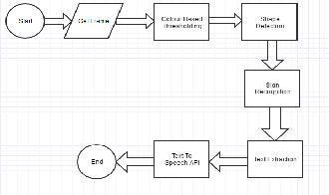

Figure 4.2: Flow Chart

4.4 Component Diagram | 15

4.4 Component Diagram
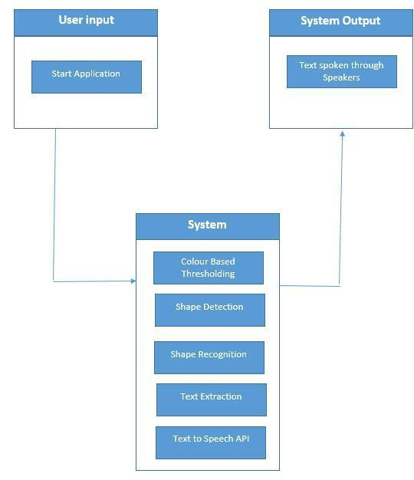

Figure 4.3: Component Diagram

16 Design

4.5 Block Diagram
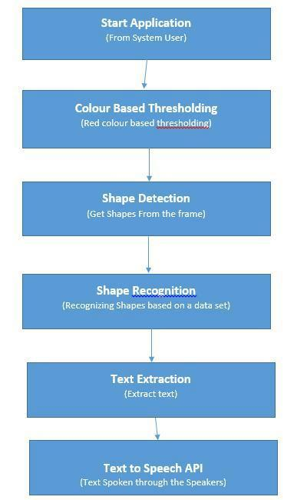

Figure 4.4: Block Diagram

4.6 Package Diagram | 17

4.6 Package Diagram
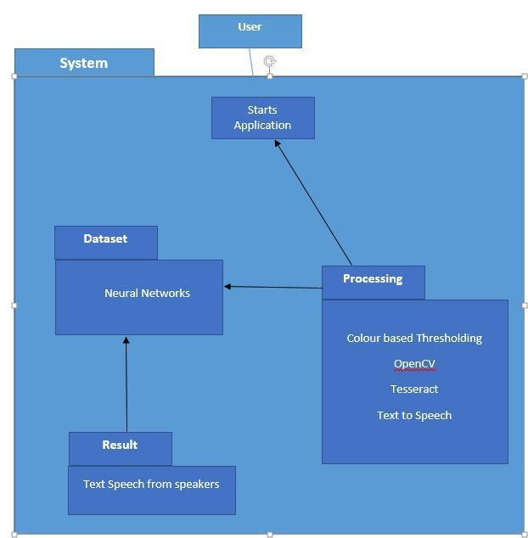

Figure 4.5: Package Diagram
18 Design

4.7 Colaboration Diagram
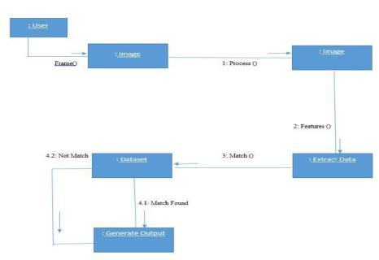

Figure 4.6: Colaboration Diagram
4.8 Sequence Diagram | 19

4.8 Sequence Diagram
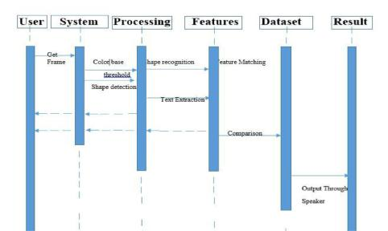

Figure 4.7: Sequence Diagram
20 Design

4.9 Deployment Diagram
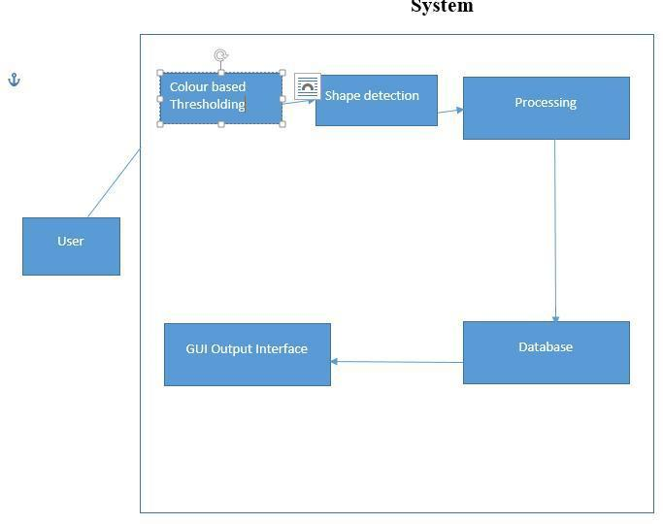

Figure 4.8: Deployment Diagram
4.10 System Overview Diagram 21

4.10 System Overview Diagram
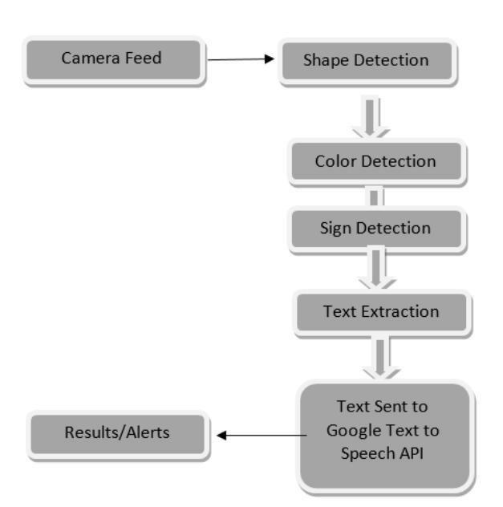

Figure 4.9: System Overview Diagram

22 Design

Chapter 5

System Implementation

In this section there is a detailed report for all algorithms, tools utilized and implementation detail of the system.

5.1 Tools and Technology

The Tools which were used for Live Traffic Road Sign Detection are as follows

Android Studio

OpenCV 3.0 for android

Java Programming language

Android Studio

Android Studio is the integrated development environment (IDE) for Android based ap-plication development. It was announced in 2013 at the Google I/O conference. Android Studio is a free software available under the Apache License 2.0.The beta stage starting from version 0.8 which was released in 2014. The first stable build 1.0 was released in December 2014, Android Studio is designed specifically for Android development.It is available for free on Windows, Mac OS X and Linux. It has replaced Eclipse An-droid Development Tools (ADT) as Google’s primary IDE for native Android application development. It was based on IntelliJ IDEA. Using IntelliJ’s powerful code editor and developer tools, Android Studio has features that can be used for developing productive applications using Android OS. Android offers more flexible Gradle-based build system, A fast and feature-rich emulator, A unified environment where you can develop for all Android devices, Instant Run to push changes to your running app without building a

23
24 System Implementation

new APK Code templates and GitHub integration to help you build common app features and import sample code, Extensive testing tools and frameworks, Lint tools to catch, performance, usability, version compatibility, and other problems, C++ and NDK support, Built-in support for Google Cloud Platform, making it easy to integrate Google Cloud Messaging and App Engine.

Open Cv 3.0

This is the library which is used for performing image processing tasks.It can be easily configured with android studio. Open CV 3.0 is one of the most stable versions provided by the Open CV.

Language

This Project is has been developed in JAVA programming language for android. This language provide flexibility and easy to use and it is the base of Android application development.

5.2 Methodology and Algorithmic Development

Resizing Canvas

Changing the size of canvas for better performance without disturbing the view of canvas. This will reduce the frame size also so that application can perform faster.The size is fixed at 640x480. OpenCv provides the camera frame setting to be changed using the object of class CameraBridgeViewBase e.g. private CameraBridgeViewBase mOpenCvCameraView; and using this object we set the max frame size according to our needs using setMaxFrame-Size(int width,int height) function e.g. mOpenCvCameraView.setMaxFrameSize(640,480);

Color Based Threshold

We have used Red Color based threshold to detect the boundaries of the traffic sign. For this step first we converted RGB image to HSV e.g. Imgproc.cvtColor(ane,dest, Imgproc.COLOR RGB2HSV), where ane and dest are two Matrix objects. Then us-ing Core.inRange() function I gave it the red color values e.g. Core.inRange(dest, new Scalar(0,50,40), new Scalar(10,255,255), thresh), where thresh is also a Matrix object in which the red color based thresholded image is present.
5.2 Methodology and Algorithmic Development | 25

Morphological Operations

There are two operations Erosion and Dialation. When Erosion is followed by Dialation then this process is called "‘Opening"’ and when Dialation is followed by erosion then this process is called "‘Closing"’. I have performed "‘Opening"’ which is a Morphological Operation.Imgproc.erode(thresh,gdest,element), Imgproc.dilate(gdest, erdest, element). After performing Opening there was still need of dialating and eroding the image for perfect results so they have been called number of times.

Canny Edge Detection

After Morphological Operations i have performed a median blur function to clear the image because the noise present in the picture can influence the outcomes so to stay away from unwanted components i have used median blur and then i have performed Canny Edge Detection to get the edges i needed. This Process is given below: Img-proc.medianBlur(ldest,erdest,1), Imgproc.Canny(erdest,dest,20,100,3,false);

Hough Transformation

Hough Transformation provides us with some good functions to detect circles and then display them on the main canvas. For this purpose i have used Hough Circles to de-tect Circles e.g. Imgproc.HoughCircles(dest,circleOut,Imgproc.CV HOUGH GRADI-ENT,2,dest.rows()/8,100,50, 0, 0), and then i have used Imgproc.circle() function to draw the circles on the main canvas e.g. Imgproc.circle(ane,new Point(x,y),radius,new Scalar(0,0,255),2).

Chapter 6

System Testing and Evaluation

6.1 Introduction

Live Traffic Road Sign Detection is an Android base Mobile Application system. By utilizing this system we will ready to detect road sign in real time. We store the information of road signs in a dataset. For detecting a road sign a frame will be processed and its features will be matched with the image in dataset to produce a result in audio.

6.2 Testing

Testing is procedure that is required to finish the product, complete in a way that product that we made is absolutely blunder and bug free. It gives partners surety that system is made by prerequisites and system is working accurately. In programming testing there are diverse structures utilized and there are numerous kind of testing to finish distinctive periods of the testing.

6.3 Usability Testing

Output of my system are fine and work validly. There are diverse calculation of my system that run properly without bug. Also, button work fine.

6.4 Project Running Testing

We take real time image frames for the system and on the basis of expected output we check our results.

27
28 System Testing and Evaluation

6.5 Compatibility Testing

Minimum requirements for this application to run is a 8mp camera with 2gb ram and 1.4 GHz processor with minimum Android Jellybean Operating System.

6.6 Test Plan

The system testing will be a nonstop procedure as approach utilized for improvement is agile. Test plan is further altered by improvement of the product. Test plan mainly includes:

Identifying the tasks and objectives of the

testing. Defining the scope of testing.

Adopting and maintain a test

strategy. Defining test cases.

Defining test methodology.

6.7 Objectives of testing

Goal of testing is to guarantee that quality of system satisfies the user. Used that method-ology which took less time for calculations. System test will approve if any necessity is not satisfied. It will likewise decide the product is giving the desired results or defective results.

6.8 Testing techniques

Dynamic and static testing are the two procedures used to test the working of software and analyzing the satisfaction of user. Dynamic testing includes the checking of work flow and its rightness, reliability and dependability. Static testing will include the incorporation of necessities of programming in the design.

6.9 Testing Scope

Interface testing figures out which system zones are usually and initially accessed. Check-ing for any interferences by user or handle any exceptions.

6.10 Test Cases
Test Cases 29

Test case ID | TC - 01
Test Description | Test that the camera view is open or not?
Requirements | Include Open Cv
Initial Condition | Camera Preview should be open
Step | Task Performed | Result/Evaluation
1. | Start Application | Pass
2. | Camera View is open | Pass

Table 6.1: Test Case-1: Getting Image

Test case ID | TC - 02
Test Description | Preview in HSV format is working or not ?
Requirements | Include Open Cv
Initial Condition | Camera Preview should be open
Step | Task Performed | Result/Evaluation
1. | Camera view open | Pass
2. | Frames are available as input | Pass
3. | conversion of RGB frame into an HSV frame | Pass
 | Table 6.2: Test Case-2: Convert Image to HSV

Test case ID | TC - 03
Test Description | Color based thresholding
Requirements | Include Open Cv
Initial Condition | HSV frame is available
Step | Task Performed | Result/Evaluation
1. | HSV frame is working | Pass
2. | Red color based threshold is working | Pass

Table 6.3: Test Case-3: Color based Thresholding

Test case ID | TC - 04
Test Description | Convert the Red color based frame into canny edge.
Requirements | Include Open Cv
Initial Condition | Red color based frames are available
Step | Task Performed | Result/Evaluation
1. | Red color based frame are available | Pass
2. | Canny edges are visible | Pass

Table 6.4: Test Case-4: Canny Edge Detection

30 System Testing and Evaluation

Test case ID | TC - 05
Test Description | Get Circles from Canny Images
Requirements | Include Open Cv
Initial Condition | Canny Edge based frames are available
Step | Task Performed | Result/Evaluation
1. | Perform Opening | Pass
2. | Perform Closing | Pass
3. | Bluring Image | Pass
4. | Get circles from frames | Pass

Table 6.5: Test Case-5: Shape Detection

Test case ID | TC - 06
Test Description | Extract Features from frames
Requirements | Include Open Cv
Initial Condition | Detected Circles are availble
Step | Task Performed | Result/Evaluation
1. | circles are detected | Pass
2. | Features are extracted | Pass

Table 6.6: Test Case-6: Features Extraction

Chapter 7

Conclusions

By working on this project I learned a lot of things. Digital image processing in Java and Android is rarely used but accept it as a challenge and I am glad that I succeeded to accomplish our challenge successfully. Get Features data is very difficult to implement but at the end I implement this and I learned a lot of new things.

7.1 Major Accomplishments

As a result we succeeded to accomplish our major objective which was to detect traffic road signs. Our system work perfectly and we evaluated its result and it give 90 Percent accurate results. Which is very good thing for me that I made a good software.

7.2 Limitations

As it is a first version of my system that’s why there are some limitation which must be taken as a high priority.

Windscreen of the car should be clean.

Light intensity should be constant.

7.3 Future Enhancements

Detect Triangle and Rectangle shaped road signs

Light source can be added on left side of car for use of this application at night.

31
32 Conclusions
33 REFERENCES

References

- Imran Siddiqi Zumra Malik. Detection and recognition of traffic signs from road scene images. 12th International Conference on Frontiers of Information Technology, 2013.

Cited on p. 5.

- Majid Mirmehdi Greenhalgh, Jack. Real-time detection and recognition of

road traffic signs. IEEE Transactions on Intelligent Transportation Systems 13.4, 48(4):27–31, April 2012. Cited on p. 5.

- R. Ganesamoorthy P. V. Nandha Kumar. Recognition of sign and text using lvq and svm. International Research Journal of Advanced Engineering and Science, Volume 1, Issue 2, pp. 118-125, 2016. Cited on p. 5.

- Sagar Moharir Arasanipalai Mohan Aditya. Study of traffic sign detection and recogni-tion algorithms. International Journal of Science and Research (IJSR) ISSN (Online): 2319-7064, 2013. Cited on p. 5.

33

